Dear *Journal of Experimental Biology* editor,

We respectfully submit “Scaling of oscillatory kinematics and Froude efficiency in baleen whales,” for consideration of publication in *Journal of Experimental Biology*.

Locomotion is inextricably tied to fitness. By quantifying how animals move, from long distance migrations to maneuvers between predators and prey, we can more fully understand the margin between life and death. Within the marine environment, various lineages have evolved convergent morphologies and mechanisms for high-performance locomotion. Oscillatory swimming in aquatic vertebrates has been studied for nearly a century, with the majority of research on small species that can be easily housed and studied in swim tunnels or aquaria. However, how our understanding of animal locomotion translates to animals in the natural environment remains poorly understood.

Fish have been the primary study system since James Lighthill FRS performed his pioneering hydrodynamics work in the 1970s. Since then, studies published in *JEB* such as Fish (1998) “Comparative kinematics and hydrodynamics of odontocete cetaceans: morphological and ecological correlates with swimming performance”and, more recently, Williams et al. (2017) “Swimming and diving energetics in dolphins: a stroke-by-stroke analysis for predicting the cost of flight responses in wild odontocetes” have examined the hydrodynamic and energetic implications of swimming in small marine mammals. But apart from Gough et al. (2019) “Scaling of swimming performance in baleen whales” there remains a dearth of information for larger swimmers and a lack of understanding for how the kinematic trends discovered in the laboratory and aquaria relate to the natural context. Researchers are starting to bring the biomechanics laboratory into the field, as demonstrated several papers also published in *JEB* by Han et al. (2017) “Field swimming behavior in largemouth bass deviates from predictions based on economy and propulsive efficiency.” And Watanabe et al. (2019) “Swimming strategies and energetics of endothermic white sharks during foraging”. There is a practical trade-off between controlled experiments in the lab and the natural performance that can be measured under field conditions. However, as animal-borne technologies (biologging and biotelemetry) become smaller and more powerful, our ability to provide high-resolution kinematic data of wild animals is increasingly possible.

Here we follow up on the biologging approach used by Gough et al. (2019) and address two new questions that relate to core principles in animal locomotion: 1) What are the hydrodynamics of oscillatory swimming at the largest scale? And 2) How does Froude (propulsive) efficiency scale with body size in the largest animals? We deployed suction-cup tags equipped with inertial sensors and cameras to quantify the kinematics of locomotion of rorqual whales from minke whales (~5 m) to blue whales (~25 m). We used calibrated drone systems to measure the size of tagged whales, thereby providing a basis for our scaling study. Our results demonstrate that large whales maintain similar oscillatory kinematics when transitioning from routine to high-effort swimming modes and show an increase in mass-specific thrust output and drag coefficient with increasing body size, but a slight decrease in Froude efficiency, while maintaining overall high efficiency (~90%) relative to other taxa.

These results have important implications for understanding the energetics of locomotion at large scales. Although the thrust power required to achieve maximum speed appears to be constrained at large body sizes, large rorquals may benefit from a low cost of transport (Williams, 1999; Gough et al., 2019). High burst velocities and accelerations attained by the whales during lunges incur reduced Froude efficiencies compared to routine and migratory velocities. The reduced Froude efficiency would place increased energetic demands during active foraging using a lunge feeding strategy for the balaenopterids. Our results are some of the first to quantify the fine-scale hydrodynamics that underlie these energetic differences between routine and energetically expensive swimming modes and include some of the largest absolute body sizes as well as a larger body size range than any previous study on swimming animals.

Yours sincerely,

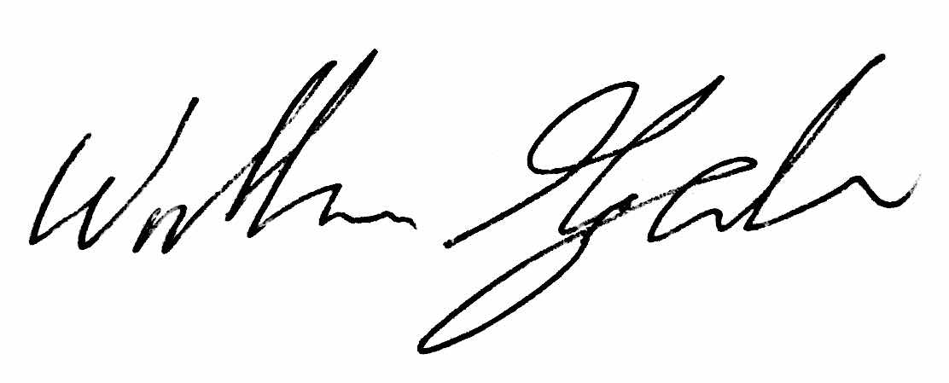

William Gough

**Suggested Referees:**

David Ellerby, Wellesley College, dellerby@wellesley.edu

Yuuki Watanabe, National Institute of Polar Research, watanabe.yuuki@nipr.ac.jp

Ann Pabst, University of North Carolina Wilmington, pabsta@uncw.edu

**References**

1. Fish, F.E. (1998). Comparative kinematics and hydrodynamics of odontocete cetaceans: morphological and ecological correlates with swimming performance. *J. Exp. Biol.* **201**, 2867-2877.
2. Han, A.X., Berlin, C. and Ellerby, D.J. (2017). Field swimming behavior in largemouth bass deviates from predictions based on economy and propulsive efficiency. *J. Exp. Biol.* **220**: 3204-3208.
3. Watanabe, Y.Y., Payne, N.L., Semmens, J.M., Fox, A. and Huveneers, C. (2019). Swimming strategies and energetics of endothermic white sharks during foraging. *J. Exp. Biol.* **222**: jeb185603.
4. Williams, T.M. (1999). Evolution of swimming in mammals. *Phil. Trans. R. Soc. Lond. B.* **354**, 193-201.
5. Williams, T.M., Kendall, T.L., Richter, B.P., Ribeiro-French, C.R., John, J.S., Odell, K.L., Losch, B.A., Feuerbach, D.A. and Stamper, M.A. (2017). Swimming and diving energetics in dolphins: a stroke-by-stroke analysis for predicting the cost of flight responses in wild odontocetes. *J. Exp. Biol.* **220**, 1135-1145.